**Assignment 2**

**CSS (Cascading style sheets)**

1. What are the benefits of using CSS?

CSS handles the look and feel part of a web page. Using CSS, you can control the color of the text, the style of fonts, the spacing between paragraphs, how columns are sized and laid out, etc.

Advantage

1. **Save time**
2. **Platform independence**
3. **Easy maintenance**
4. Easy for the user to customize the online page
5. **Dis-advantage**

There exists a scarcity of security.

There might be cross-browser issues while using CSS.

Browser compatibility (some styles sheet are supported and some are not).

1. **Difference between CSS2 and CSS3**

|  |  |
| --- | --- |
| **Css** | **Css3** |
| CSS does not support responsive design. | CSS3 is the latest version and supports the responsive design. |
| CSS is not divided into modules. | CSS3 could split into modules. |
| CSS cannot produce 3D animation and transformation. | All kinds of transformations and animations are performed by using CSS3. |
| CSS provides unique color schemas and standard color. | CSS3 supports HSL RGBA, HSLA and the gradient colors. |

1. **Name a few CSS style components**

**The components of css style are:**

1)Selector:HTML element name, id name, class name.  
2)Property: It’s like an attribute such as background color,font-size,position,text- align,color,border etc.  
3)Values:which defines property or values allocate for properties.

1. **What do you understand by CSS opacity**

The **opacity** CSS property sets the opacity of an element. Opacity is the degree to which content behind an element is hidden, and is the opposite of transparency.

**opacity: 0.9;**

**opacity: 90%;**

**/* Global values */**

**opacity: inherit;**

**opacity: initial;**

**opacity: revert;**

**opacity: revert-layer;**

**opacity: unset;**

1. **How can the background color of an element be changed?**

e.g. body {  
background-color: red;  
}

1. **How can image repetition of the backup be controlled?**

To control the repetition of an image in the background, **use the background-repeat property**. You can use no-repeat value for the background-repeat property if you do not want to repeat an image, in this case, the image will display only once

1. **What is the use of the background-position property?**

The background-position property **sets the starting position of a background image**. Tip: By default, a background-image is placed at the top-left corner of an element, and repeated both vertically and horizontally.

1. **Which property controls the image scroll in the background?**

The background-attachment property sets whether a background image scrolls with the rest of the page, or is fixed.

**10. Why should background and color be used as separate properties?**

**There are two reasons behind this:**

* It enhances the legibility of style sheets. The background property is a complex property in CSS, and if it is combined with color, the complexity will further increase.
* Color is an inherited property while the background is not.
  1. **How to center block elements using CSS1?**

With css the way to center anything that's a block level element is **with the margin property**. One of the values of margin is auto and by setting auto on the left and right margin our block level element will center itself.

* 1. **How to maintain the CSS specifications?**

The Specification **defines how CSS properties should be implemented by browser vendors along with detailed algorithms, code samples and tabular information**. The Specification also include: The syntax and data types of the language. Detailed explanation on CSS Selectors

**13. What are the ways to integrate CSS as a web page?**

CSS can be added to HTML documents in 3 ways: **Inline - by using the style attribute inside HTML elements**. Internal - by using a <style> element in the <head> section. External - by using a <link> element to link to an external CSS file

**14. What is embedded style sheets?**

**Embedded Stylesheet:**It allows you to define styles for a particular HTML document as a whole in one place. This is done by embedding the **<style></style>** tags containing the CSS properties in the head of your document.

15**. What are the external style sheets?**

An external style sheet is **a separate CSS file that can be accessed by creating a link within the head section of the webpage**. Multiple webpages can use the same link to access the stylesheet. The link to an external style sheet is placed within the head section of the page.

**16. What are the advantages and disadvantages of using external style sheets?**

**Advantages**

* With the help of External Style Sheets, the styles of numerous documents can be organized from one single file.
* In External Style Sheets, Classes can be made for use on numerous HTML element types in many forms of the site.
* In complex contexts, Methods like selector and grouping can be implemented to apply styles.

**Dis-advantage**

extra download is essential to import style information for each file.

The execution of the file may be deferred till the external style sheet is loaded.

While implementing style sheets, we need to test Web pages with multiple browsers in order to check compatibility issues.

1. **What is the meaning of the CSS selector?.**

CSS selectors are used to "find" (or select) the HTML elements you want to style.

**Types**

Element selector

Id selector

Class selector

Universal selector

Multivalued selector

1. What are the media types allowed by CSS?

  two ways to specify media dependencies for style sheets −

* Specify the target medium from a style sheet with the @media or @import at-rules.
* Specify the target medium within the document language.

<style tyle = "text/css">

<!--

@media print {

body { font-size: 10pt }

}

@media screen {

body { font-size: 12pt }

}

@media screen, print {

body { line-height: 1.2 }

}

-->

</style>

1. What is the rule set?

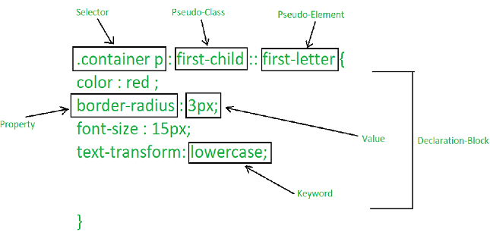

A CSS ruleset is **various affirmations to various pieces or elements of the document**.

1. Create Layouts